How to Power and Control Brushless DC Motors

This document will provide a comprehensive literature review on all aspects of BLDC motor power and control. The review will cover the following topics:

* **System breakdown structure**: A high-level overview of the different components that make up a BLDC motor system, and how they interact with each other:
  + **Controller**
  + **Gate Drivers**
  + **Phase-Inverters**
  + **Power Supply**
  + …
* **Component selection:** A discussion of the different components that need to be selected to build a BLDC motor system, such as drive gates, microcontrollers, and power supplies.
* **PCB Design:** Explore PCB design principles, including layout considerations, component placement, and how to minimize noise and interference.
* **Case Studies:** Include case studies or examples of successful BLDC motor systems and the lessons learned from those projects.
* **Safety and Protection:** Address safety mechanisms, fault detection, and protection measures to prevent damage to the motor and control system.
* **…**

The goal of this review is to have a deep understanding of BLDC motor power and control, so that I can design and build my own BLDC motor systems for a certain motor.

**Bibliography used in this document:**

[1] - [Hardware Engineer’s Guide to a Brushless-DC Motor Controller: Design and challenges](https://ieeexplore.ieee.org/abstract/document/9715975)

* Discusses the different components of a typical BLDC motor system and how they interact with each other.
* Provides design considerations for BLDC motor controllers, including power trace sizing, grounding and shielding, heat dissipation, and component placement and routing.
* Highlights the challenges of designing BLDC motor controllers, such as high voltage and high current requirements, and the need to maintain high efficiency.

[2] - [How to Power and Control Brushless DC Motors](https://www.digikey.com/en/articles/how-to-power-and-control-brushless-dc-motors)

* Provides guidance on component selection for BLDC motor systems.
* **Designing a BLDC motor:** Section that matters the most, comparison and uses of different components and their advantages

[3] - [A Rapid Development Method on Brushless DC motor Controller](https://ieeexplore.ieee.org/abstract/document/4375143)

* Proposes a rapid development method for BLDC motor controllers, including the design and technical aspects of the controller.
* Discusses the different stages of the development process, including hardware design, software development, and testing.
* Provides a case study of a BLDC motor controller that was developed using the proposed method.

[4] - [Design and Implementation of Brushless DC Motor Drive and Control System](https://www.sciencedirect.com/science/article/pii/S1877705812003013)

Literature Review

1. Hardware Engineer’s Guide to a Brushless-DC Motor Controller: Design and challenges, [[1]](https://ieeexplore.ieee.org/document/9715975/authors#authors) (This article lays the guidelines for designing a BLDC motor drive PCB)

* Components of typical BLDC Motor Controller:

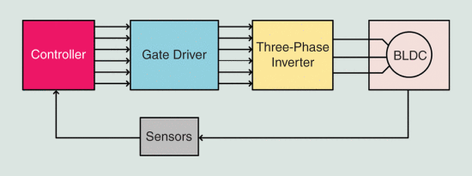

* 1. **Controller**: The controller can be a **microcontroller**, digital signal processor (DSP), field-programmable gate array (FPGA), or any hardware-in-loop (HIL) simulation hardware. Its task is to **provide the commutation signals** to the inverter through gate drivers. Depending on the commutation type and control method, the controller assesses the motor parameters and input from the inverter through various sensors. The controller uses the motor parameters and end-user requirements to generate the control signals to drive the motor as desired.
  2. **Gate Driver:** Various off-the-shelf gate drivers are available in different configurations dependent on the level of integration that it’s desired.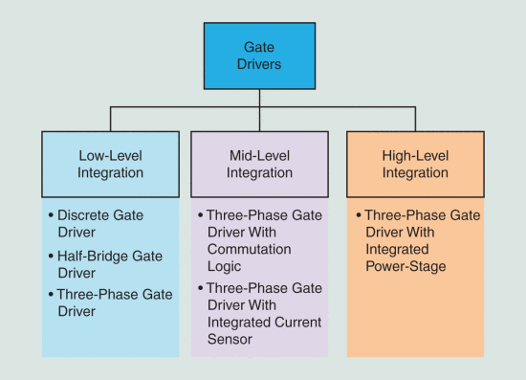

This article presents a design guideline for the hardware development of motor controllers with medium-level integration gate drivers. The article focuses on three-phase integrated gate drivers with an external power stage.

* 1. **3-Phase Inverter:** The inverter is a combination of three half H-Bridges connected to a common DC rail with the midpoints of H-Bridge legs serving as motor connection points. These are also available in discrete switch, half H-Bridge, and three-phase module forms. The selection of the MOSFETs or modules to design the inverter depends on the design constraints and motor ratings.
  2. **Sensors:** BLDC motors require different sensors to drive the motor properly. Speed control can be achieved with or without a speed sensor and implemented as sensored or sensorless control. The most common sensors associated with BLDC are **hall-effect sensors**, which provide the **sectorial rotor position** depending on the placement of hall-sensors. More accurate **resolvers or encoders can be used when position control is required.** The phase current and voltages are also required for more complex controls like field-oriented control (FOC), so **external current sensors or integrated current sense amplifiers** are used.
* Why Integrated BLDC Motor Controller (Discrete vs Integrated Gate Drive)

End-use constraints are the first concern of a design engineer. In the case of BLDC motors, efficient operation and excellent dynamic response are required. There are many ways to spin a BLDC motor, for example, trapezoidal commutation, sinusoidal commutation, and FOC. The first two offer simple to control but lack the optimal speed and torque response. It **has been established that the optimal and efficient speed control of the BLDC motor is achieved by the FOC method providing the best dynamic speed response and low-speed operation.** However, for FOC implementation, the phase voltages and currents need to be measured accurately. The integrated gate drivers can help solve this challenge by providing **in-built current sense amplifiers**, which sense current from low-cost sense resistors connected to the ground side of three half H-Bridge legs.

The second major concern of the design engineer is the system cost. Discrete gate drivers give flexibility in power rating, but it comes at the cost of an increased bill of material (BOM) due to the many discrete components. Each discrete gate driver requires an external power supply for biasing and other passive components to work optimally. However, **integrated gate drivers can include internal LDOs** (Low-dropout linear regulators, [[LDO]](https://www.rohm.com/electronics-basics/dc-dc-converters/what-is-ldo), it’s basically a DC-DC converter) **to power the device from the common voltage rail** and not require an external power supply. Integrated drivers **require minimal external passive components.** With a reduced number of components, the footprint required on PCB to provide the solution can be minimized, helping the design engineer make the design compact.

Table I.- Design Differences with Discrete and Integrated Gate Driver.


A comparative analysis showing the pros and cons of a motor controller designed with a discrete gate driver and integrated gate driver configuration.

**Conclusion on Discrete vs Integrated gate drivers:** Discrete gate drivers give the designer **flexibility** to design the motor controller for a **wide output power** requirement and choose the optimal arrangement of other components. However, the design requires **many discrete circuits** and therefore is **costly and complex.** The motor controller design for a **high voltage motor can only be achieved using discrete or half H-Bridge gate drivers.** However, battery-operated hand-held portable tools or robotics applications utilize lower operational voltages. Cost and weight need to be minimized in these systems, so the integrated gate drivers are the best choice. There are hundreds of integrated gate drivers with different configurations available on the market. The system designer must make the design decisions to trade-off between cost, size, and complexity.

* Design Constraints and Component Selection

Guidelines for designing PCB for a real-time application for a spindle motor drive utilizing a FOC algorithm. This system is designed for speed control and uses a low-side single-shunt current measurement to reconstruct phase currents and a voltage divider circuit at each phase output for phase voltage measurement.

The ratings of the BLDC motor govern the design requirements of the motor controller hardware. This article gives the readers key specifications. The key components required for the complete solution and their key specs to be met are:

**Gate Driver**—This component should be capable of driving six discrete MOSFETs, and as a rule of thumb, the voltage rating of the gate driver should be at least twice that of the rated motor voltage for a high-power system. If FOC control is required, the gate driver should have the capability to support a six-PWM mode interface. This design requires only one current measurement, and so we select a gate driver with at least one current sense amplifier. Gate drivers support a 3.3 V or 5 V logic level, and the device should be selected to support the target logic voltage; otherwise, a level shifter circuit will be required. Another critical design constraint is **the gate driving current capability; a higher current gate driving capability allows a maximum switching frequency.**

**MOSFET**—Key specs to be considered while choosing the MOSFET.

Table III.- Switch Specifications.


**Sense Resistor**—Selection of a sense resistor depends on the rating of the current sense amplifier (CSA). A proper design considers the trade-off between the highest voltage at the CSA input and the sense resistor’s power loss (ohmic loss). This trade-off can be achieved by the optimal solution of equations (1) and (2).

Vcsa=IM×A×Rsense (1)

Ploss=IM^2×Rsense (2)

Where A is the Vcsa gain and Ploss is ohmic power loss in the sense resistor.

**Peripheral Passives**—A gate driver requires some passive components for a proper operation like gate drive resistors, charge pump capacitors, and decoupling capacitors which vary from part to part. The datasheet should be followed for the selection of such components.

**Connectors**—The connectors should be carefully chosen for PCB mounting. Power connectors chosen should respect the current ratings of the BLDC motor and input supply. One key constraint is the mating cycle, which should be high for plug-and-play devices, while the solder pads work best with epoxy coatings for fixed connection use cases.

* Design Constraints and Component Selection (Key PCB design constraints and the ways to mitigate them are discussed, the article has several relevant images that will help to understand this constraints)

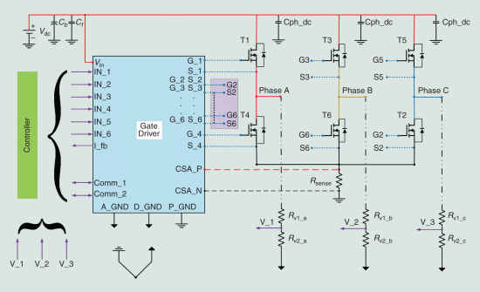

* + 1. **Grounding**—The most crucial factor in designing a mixed-signal PCB is grounding. Every signal on the PCB requires a return path, and ideally, every signal must have the return path as short as possible to minimize the loop area. Every loop on the PCB can be an antenna that radiates electromagnetic emissions. However, it is not always possible to have the return path associated with every signal; in such cases, the ground plane provides the closest return path. The best way to ensure the minimal loop is to use a four-layer PCB with the dedicated ground plane. This setup ensures noise immunity in the signals; however, the two-layer PCB can also provide a gridded ground plane in cost-constrained designs.

The signal ground and power ground should not be the same; these two planes should be connected with a small trace or net tie, as shown in the schematic. The signal ground analog (A_GND) and digital (D_GND) are separated from the power ground (P_GND) but connected with a small trace.

* + 1. **Cable Radiated Emissions**—Connecting cables are the source of electromagnetic emissions and electromagnetic interference. The connecting cables can also act as radiating antennas and make the signals susceptible to noise. Therefore, connectors should be placed on only one side to mitigate these issues.
    2. **Gate Driving Loops**—For the best switching performance, the end goal is to minimize the current loop length for the high-side and low-side gate drivers. The high-side loop is from the G_1 to the power MOSFET (T1) and returns through S_1. The low-side loop is from the G_4 to the power MOSFET (T4) and returns through S_4. It is recommended to use 15−20 mil wide traces to support higher gate driving currents and minimize gate drive inductance and impedance. Wide traces have less inductance, and shorter traces have lower impedance. Improperly designed gate drive traces add significant inductance and cause gate drive turn on/turn off issues and cause gate drive faults, worse EMI performance, and charge pump undervoltage.
    3. **Routing Switching Signals**—While routing a switching signal, right-angled traces should never be used as they form a radiation antenna. They should always be connected at obtuse angles. Examples of worst and best routing for a switching signal are shown in Figure 6.
    4. **Role of Decoupling and Bypass Capacitors**—The supply from the battery powers the motor; however, rapid motor transients are supplied by the on-board bulk capacitor Cb (shown in Figure 3). Bulk capacitors are generally electrolytic and should be placed at the input terminal; these capacitors mitigate the low-frequency ripples in the supply. Another set of filters Cf-generally ceramic capacitors—filters out the high-frequency ripple. These components can be seen in Figure 3. There are additional capacitors provided (Cph_dc) near each leg. These capacitors also act as decoupling capacitors in addition to the bulk capacitor. These components should be placed near the top side of MOSFET as close as possible.
    5. **High Current Routing**—The traces from the battery to the MOSFET and the motor connection must conduct a very high current. For such high current applications, the thickness of copper chosen for PCB should be at least 2 oz. This provides higher current carrying capacity as well as better thermal management. Often for high current capability, polygon pours of copper are used instead of traces. Still, the polygon pours should be as short and wide as possible to minimize the inductive effect. Several vias can also be added to stitch traces or polygon pours on multiple layers to conduct high current, as shown in Figure 7.
    6. **Thermal Management**—With high-level integration and high current capacity, these integrated gate drivers and MOSFETs dissipate power from ohmic loss (RDSon). A design engineer takes every step to minimize these losses, but they cannot be eliminated. The best way to provide thermal management is to provide copper pours for the components with high power dissipation. Thermal vias also help in transferring heat from the power devices. As shown in Figure 7, we can see that MOSFETs T1 to T6 have solid copper beneath them with thermal vias to transfer heat away from the components. A combination of thermal vias with solid copper acts as a miniature heat sink and is the best ally of design engineers for thermal management.
    7. **Current Measurement**—FOC algorithms require accurate current sensing. Therefore, the sense resistor and the sense amplifier design are critical. A Kelvin connection ensures the accuracy of the current measurement by providing a four-wire connection, as shown in Figure 8. The two points acting as signal points can also be routed as differential pairs for better accuracy and easy routing.

1. How to Power and Control Brushless DC Motors, [[2]](https://www.digikey.com/en/articles/how-to-power-and-control-brushless-dc-motors) (Contributed By DigiKey's North American Editors)

* Abstract and contextualization:

The brushless DC (BLDC) motor’s increasing popularity is due to the use of electronic commutation. This replaces the conventional mechanics comprised of brushes rubbing on the commutator to energize the windings (‘bobinas’) in the armature of a DC motor.

Electronic commutation provides greater efficiency over conventional DC motors with improvements of 20 to 30% for motors running at the same speed and load. As the International Energy Agency reports that 40% of all global electricity is used to power electric motors, such efficiency gains become compelling.

Further, the BLDC motor is more durable. It retains its high performance while the efficiency and power of an equivalent conventional motor declines due to wear, causing poor brush contact, arcing between the brushes and the commutator dissipating energy, and dirt compromising electrical conductivity.

Greater efficiency allows BLDC motors to be made smaller, lighter and quieter for a given power output, further increasing their popularity in sectors such as automotive; white goods; and heating, ventilation and air conditioning (HVAC). Other advantages of BLDC motors include superior speed versus torque characteristics (with the exception of torque at start-up), a more dynamic response, noiseless operation, and higher speed ranges.

The downside of BLDC motors is their complexity and the associated increase in cost. Electronic commutation demands supervisory circuits to ensure precise timing of coil energization for accurate speed and torque control, as well as ensuring the motor runs at peak efficiency.

Fortunately, this sector is rapidly maturing and silicon vendors now offer a wide range of highly-integrated BLDC motor driver power MOSFET chips with either external or embedded microcontrollers to simplify the design process, while also lowering component costs. This article will explain how the designer can take advantage of these latest chips to ease the design process